# **Introduction**

## **1.1 Why IDP/UDP?**

We have selected a UDP Project because we were not able to get in contact with any industrial identity which had a similar problem statement as we developed. We together as a team came up with the given problem statement and aim to develop the project to resolve the problem.

## **1.2 Why IDP/UDP?**

### **Learning Needs Matrix**

### **The conclusion from Reverse Engineering**

## **1.3 Project Summary**

We aim to develop a chatbot which can be used to answer queries of students and well as faculties related to a particular engineering college. Our goal is to solve the problem of time-consuming browsing of college websites as well as physical contact required to get the queries answered. A chatbot is a computer program that can converse with the user in natural language and solve their queries.

## **1.4 Objectives of the project**

To develop an efficient and effective chatbot to solve queries of students and faculties related to a particular academic institution.

## **1.5 Problem Specifications**

## **1.6 Technology Used**

* Python
* RASA framework
* Natural Language Processing
* Machine Learning
* Artificial Intelligence
* Database

## **1.7 Hardware-Software Used**

* PyCharm Community Edition
* Command Prompt Windows
* A system with 8GB RAM, 2GB NVIDIA Graphics, 1TB Hard-disk, Windows 10 Operating System.

# **System Analysis**

## **2.1 Study of the Current System**

In the olden days’ students had to visit the college to enquire about details and other information about the college, which is a time-consuming process as well as a lengthy procedure for both parents as well as students. Nowadays there are many changes occurred in the Education system with help of advanced technological improvements. Everything is happening over the internet without any difficulty.

In those days for submitting a small application also, we have to visit that place, but as the days are passing away it’s completely changing. Collecting the applications manually will be a hectic procedure and it also needs manpower. For reducing that manpower and such difficulties many devices or systems emerged day by day.

## **2.2 Problem and weakness of the Current System**

Due to the lack of information, many students faced problems in paying fees and thus deadlines get passes and they have to pay penalty fees. The same problem occurred in the filling of the scholarship form.

This system fails to provide quick guidance. We have to go to the college for collecting the information regarding any problems.

## **2.3 Requirement Analysis**

* Tools used:
  + A system with 8GB RAM, 2GB NVIDIA Graphics, 1TB Hard-disk, Windows 10 Operating System.
  + PyCharm Community Edition
* Techniques used:
  + Natural Language Processing
  + Parsing and Substitution

## **2.4 Brief Literature Review and Prior Art Search (PAS)**

* **Components of Chatbot Application:** 
  + The main components of the Chatbot are:
  + UI: The user interface is simple with not many colors. It is kept as simple as possible to make it look like a college chatbot. It consists of a text box at the bottom where the user may write the queries. A “send” button is placed to send the query to the bot. The UI is to be created using HTML, CSS, and JavaScript. [1]
  + Back-end: There are three phases:
    - Parsing and Substitution: Whenever a user types a query, it is passed on to a class that parses the input and then substitutes words and phrases with other words and phrases so that a grammatically correct statement can be generated. It is carried out using XML and Python. [1]
    - Natural Language Processing: NLP is required so that the data which is parsed can be “understood” by the application. E.g. a user’s humor, feelings, names, and places mentioned in the input. NLP is not implemented in the project but can be implemented if needed in the future. [1]
    - Database: There are various database files in the database folder with $.aiml$ extension. These are the files that contain the various patterns of the conversations. [1]
* **NLP:** 
  + It is a part of artificial intelligence that deals with human languages. It has the following structure:
    - Application
    - NLP Layer
    - Knowledge Base
    - Data Storage
  + NLP is divided into two very important components:
    - Natural Language Understanding: It is mostly used to map inputs to useful representations. It is also helpful in analyzing different aspects of the language.
    - Natural Language Generation: It is generally used text planning, sentence planning, and text realization. NLP is implemented using a library in Python named NLTK.
  + There are some steps followed in NLP:
    - Tokenization: It is the process to break a complex sentence into words. Also, the importance of each word is understood concerning the sentence. It also helps to produce a structural description of an input sentence.
    - Stemming: It is the process in which words are normalized into its base form or root form.
    - Lemmatization: It is the process in which grouping of different inflected forms of a word is done. It also roots several words into one common root but the output of Lemmatization is a proper word.
    - Stop Words: These are some of the words which are helpful to make a sentence meaningful but do not help in NLP.
    - Parts of Speech: It is an inbuilt library containing various parts of speech.

## **2.5 Design: Analysis, Design Methodology, and Implementation Strategy**

* AEIOU Summary Canvas:

Fig 2.5.1: AEIOU Summary Canvas

* + Students, faculty, and parents can use this chatbot to get quick response and guidance regarding placements, academic details, latest updates, and also the department’s information.
  + The objects required for the use of chatbot are mobile/PC/laptop, internet.
* ****Ideation Canvas:

Fig. 2.5.2: Ideation Canvas

* + People: Managing staff, students, faculty, staff members, parents.
  + The chatbot can guide college members, hostel members, departments, and library members.
  + The other tools which can be used for making chatbot are rasa, Alexa, dialog flow, AI voice bot.
* Empathy Canvas:



Fig. 2.5.3: Empathy Canvas

* Users are: faculty, managing staff, parents, students
* Students can get information about paying fees and scholarship information in no time. So the problems faced by the students of paying penalty fees can be solved by using this chatbot as it gives a quick response.
* Product Development Canvas:



Fig. 2.5.4: Product Development Canvas

* The components required are mobile, laptop, and internet.
* The product gives us a quick response, also easily accessible to all the users.
* Customer Revalidation: User-friendly product.
* The purpose is to give correct information, quick and easy response.

# **Project Management**

## **Project Planning and Scheduling**

### **3.1.1 Project Development Approach**

Step-1: Gather information about how a chatbot works.

Step-2: Divide the working and architecture of the chatbot into different components.

Step-3: Design a graphical framework to get an idea about the position of components in the process.

Step-4: The three main components of a chatbot are NLP, Processing, and Database.

Step-5: Create a prototype through a framework to understand the working of the chatbot.

Step-6: Gather information about NLP and improve its efficiency for the chatbot.

Step-7: Gather information about Databases to have less overhead in the process.

Step-8: Create an efficient program to process the NLP output and search the Database.

Step-9: Combine all the components.

Step-10: Train the chatbot to improve its efficiency.

Step-11: Deploy the chatbot.

Note: Step 1-4 are to be completed in Semester 7, Step 5-7 are to be partially completed in Semester 7 and to be fully completed in Semester 8, Step 8-10 are to be completed in Semester 8.

### **3.1.2 Project Plan**

The Project Plan is the same as the steps mentioned above.

# **System Modeling**

## **Dataflow Diagrams**

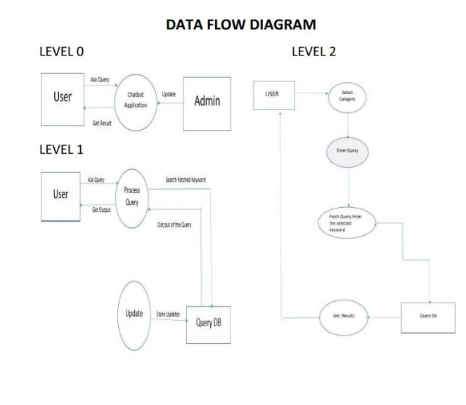

Fig. 4.1: Dataflow Diagrams [1]

## **Use Case Diagram**



Fig 4.2: Use Case Diagram [1]

User's text input will be the input to the chatbot then NLP will be performed on the text and based on the semantic, the query will be divided into three subdivisions.

* Personal Query Response System,
* AIML Response System, and
* Query Analysis and Response System.

Based on the subdivisions, answers will be separately stored so it becomes easy to search the database, then the final response will be generated by the chatbot based on its understanding of the query.

## **Activity Diagrams**

* Personal Query Response Activity:



Fig. 4.3.1: Personal Query Response Activity [1]

* Normal Conversation Response Activity:

Fig. 4.3.2: Normal Conversation Response Activity [1]

* College-Related Response Activity:



Fig. 4.3.3: College-Related Response Activity [1]

## **Sequence Diagram**

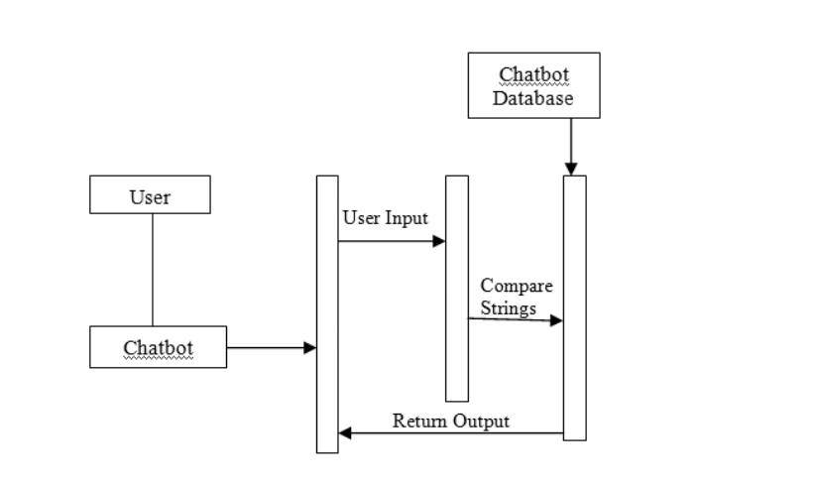

Fig. 4.4: Sequence Diagram [2]

## **State Transition Diagram**

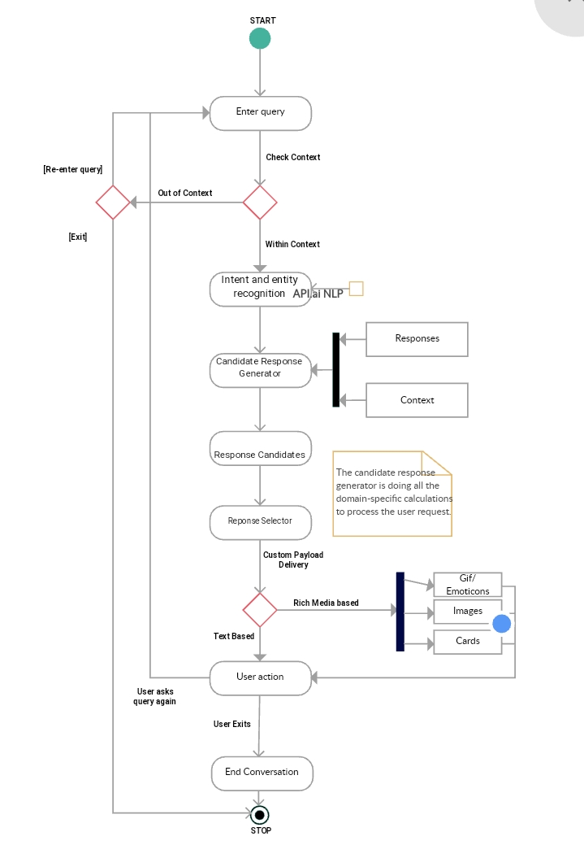

Fig. 4.5: State Transition Diagram [3]

## **System Architecture**

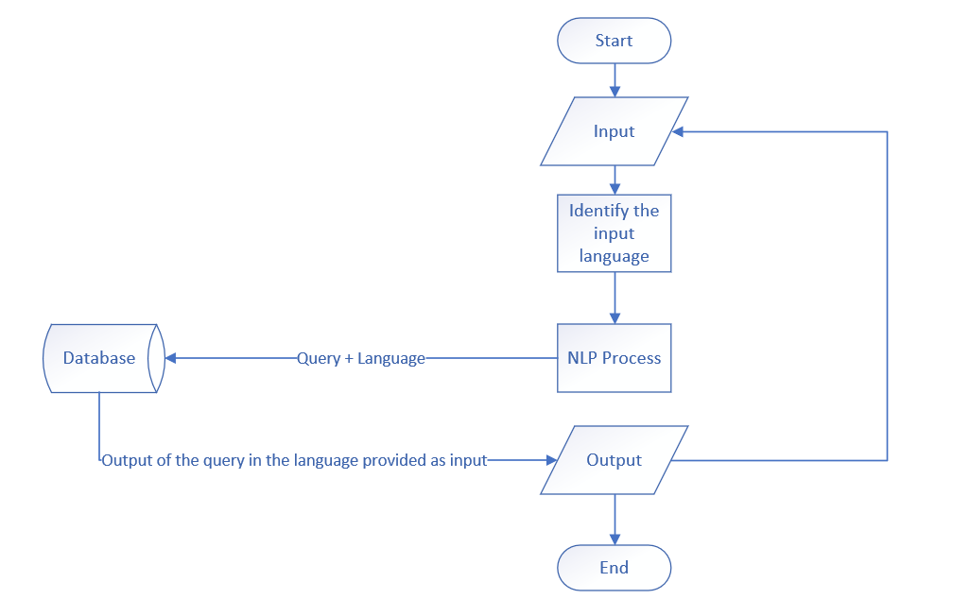

Fig. 4.6: System Architecture

# **Engineering of Economics Design**

## **Market Demand**

Automation has always been in demand in the market. We aim to develop a product that can solve common user queries so the waiting time for unique queries decreases. Also, due to COVID-19, the demand for such products has increased as people now prefer less physical contact.

## **Your Business Strategy**

Our strategy is to currently develop a product that is focused on solving the queries of a particular institution. Then, we aim to expand our product with any customization required for different clients.

## **Your Service**

Our service is to deploy the chatbot where the client requires it and then maintain the product, i.e. updating the database and maintenance check.

## **Who is your Client?**

Our client is an institution or company that requires its employees or clients to access their sites frequently for information.

# **Conclusion and Future Scope**

* Our product will help the clients as well as employees of any institution or company to get their queries answered more efficiently than ever.
* Currently, we are preparing the product for an educational institution and we aim to expand our product’s limit to every field possible.
* We also aim to improve the efficiency of our product through the timeline simultaneously.

# **References**

1. College Enquiry Chat Bot by Karanvir Singh Pathania of Jaypee University of Information and Technology Waknaghat, Solan – 173234, Himachal Pradesh. (<http://122.252.232.85:8080/jspui/bitstream/123456789/22765/1/College%20Enquiry%20Chat%20Bot.pdf>)
2. Dahiya, Menal. (2017). A Tool of Conversation: Chatbot. INTERNATIONAL JOURNAL OF COMPUTER SCIENCES AND ENGINEERING. 5. 158-161. (<https://www.researchgate.net/publication/321864990_A_Tool_of_Conversation_Chatbot/link/5a360b02aca27247eddea031/download>)
3. A chatbot (Activity Diagram (UML)) by Mohammed Abrar Ahmed (<https://creately.com/diagram/example/j1q6u9ue2/Chatbot>)